CS 255 System Design Document Template

This template lays out all the different sections that you need to complete for Project Two. Each section has guidance to prompt your thinking. You will need to continually reference the interview transcript as you work to make sure that you are addressing your client’s needs. There is no required length for the final document. Instead the goal is to complete each section based on what your client’s needs are. Remove this note when you are finished, and replace all bracketed text with the relevant information.

UML Diagrams

UML Use Case Diagram
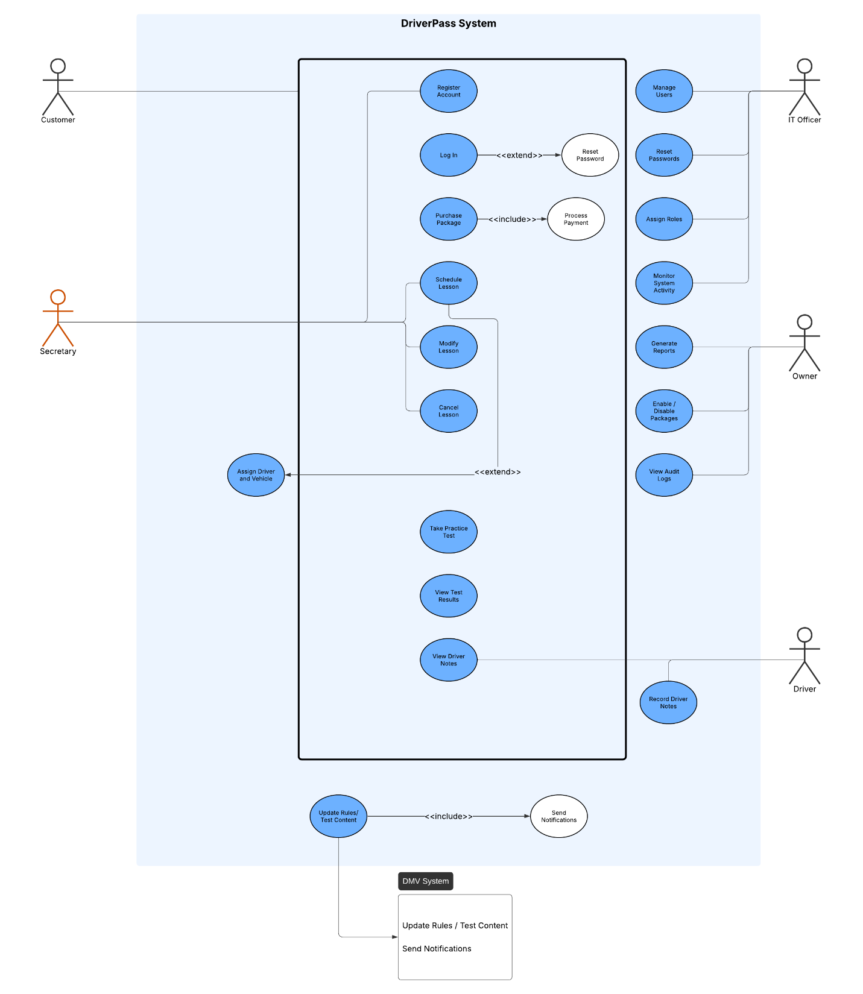

UML Activity Diagrams
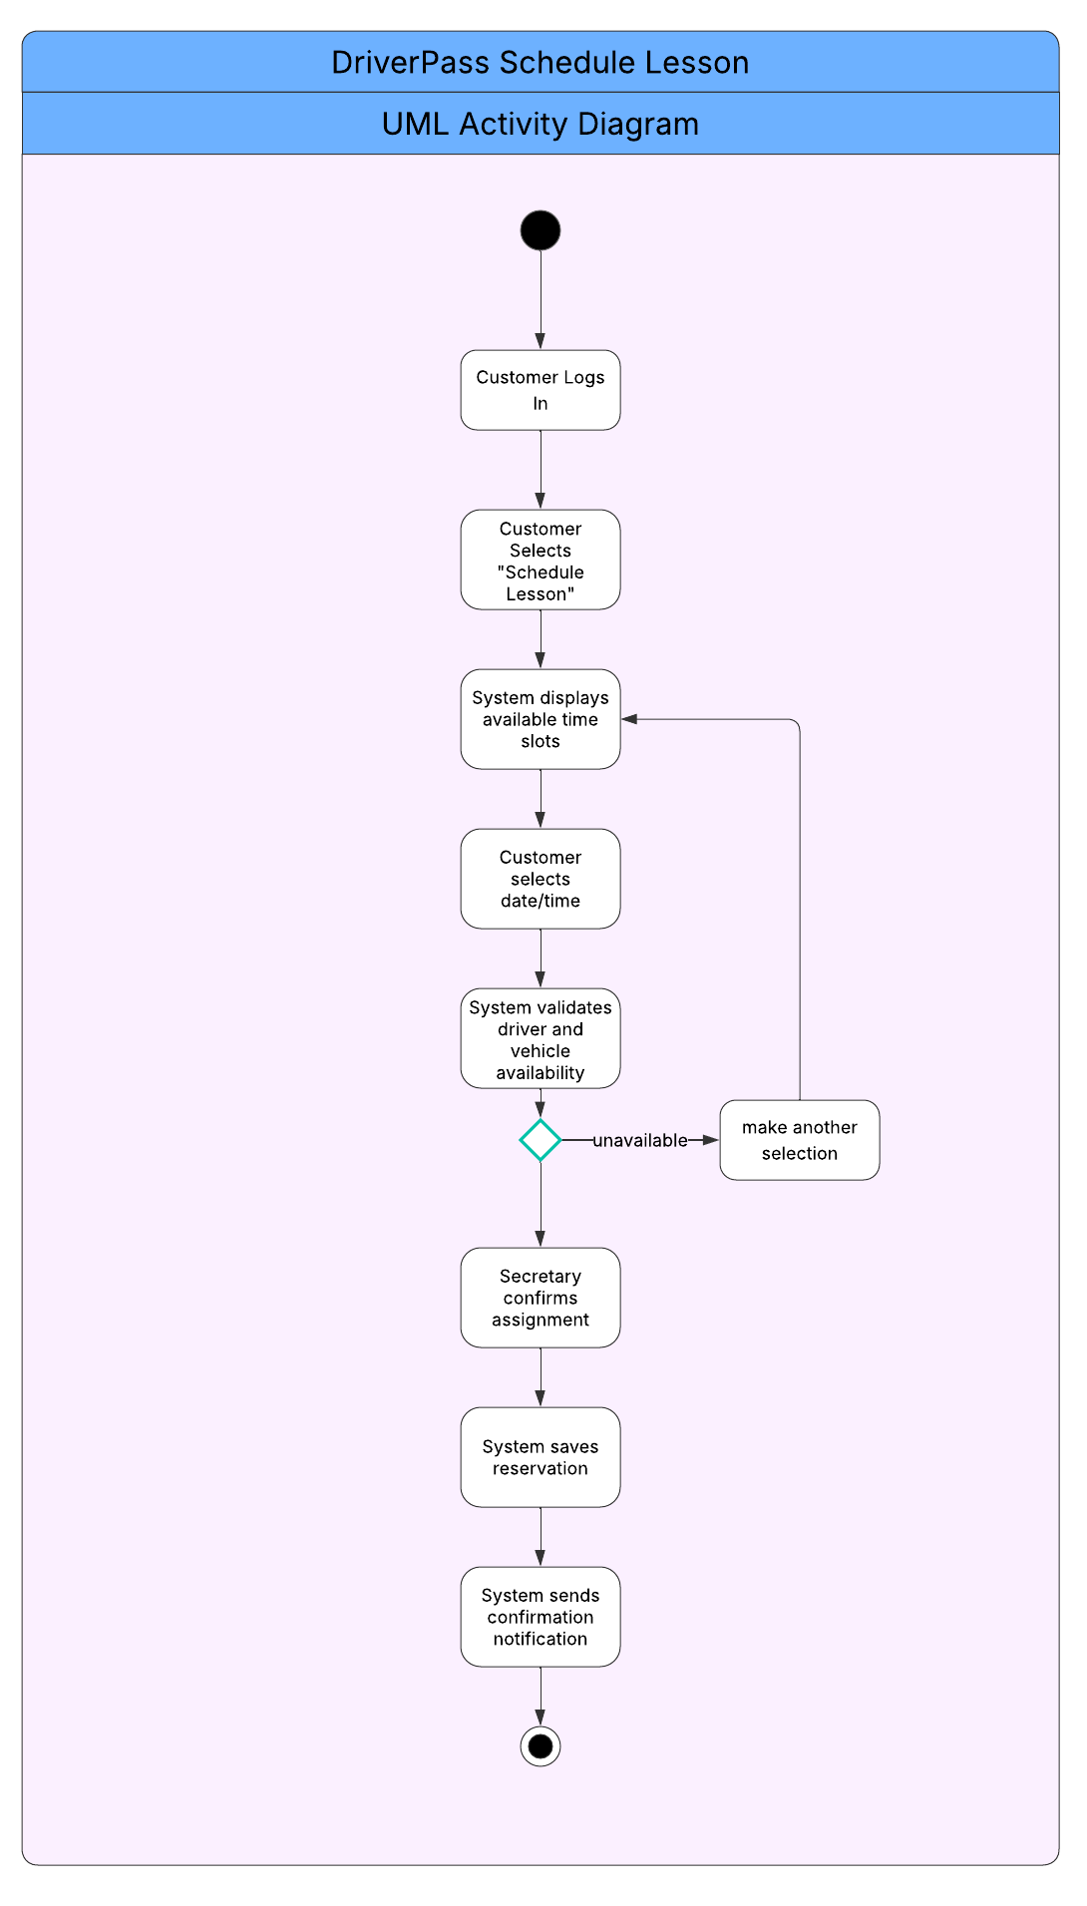
1/2

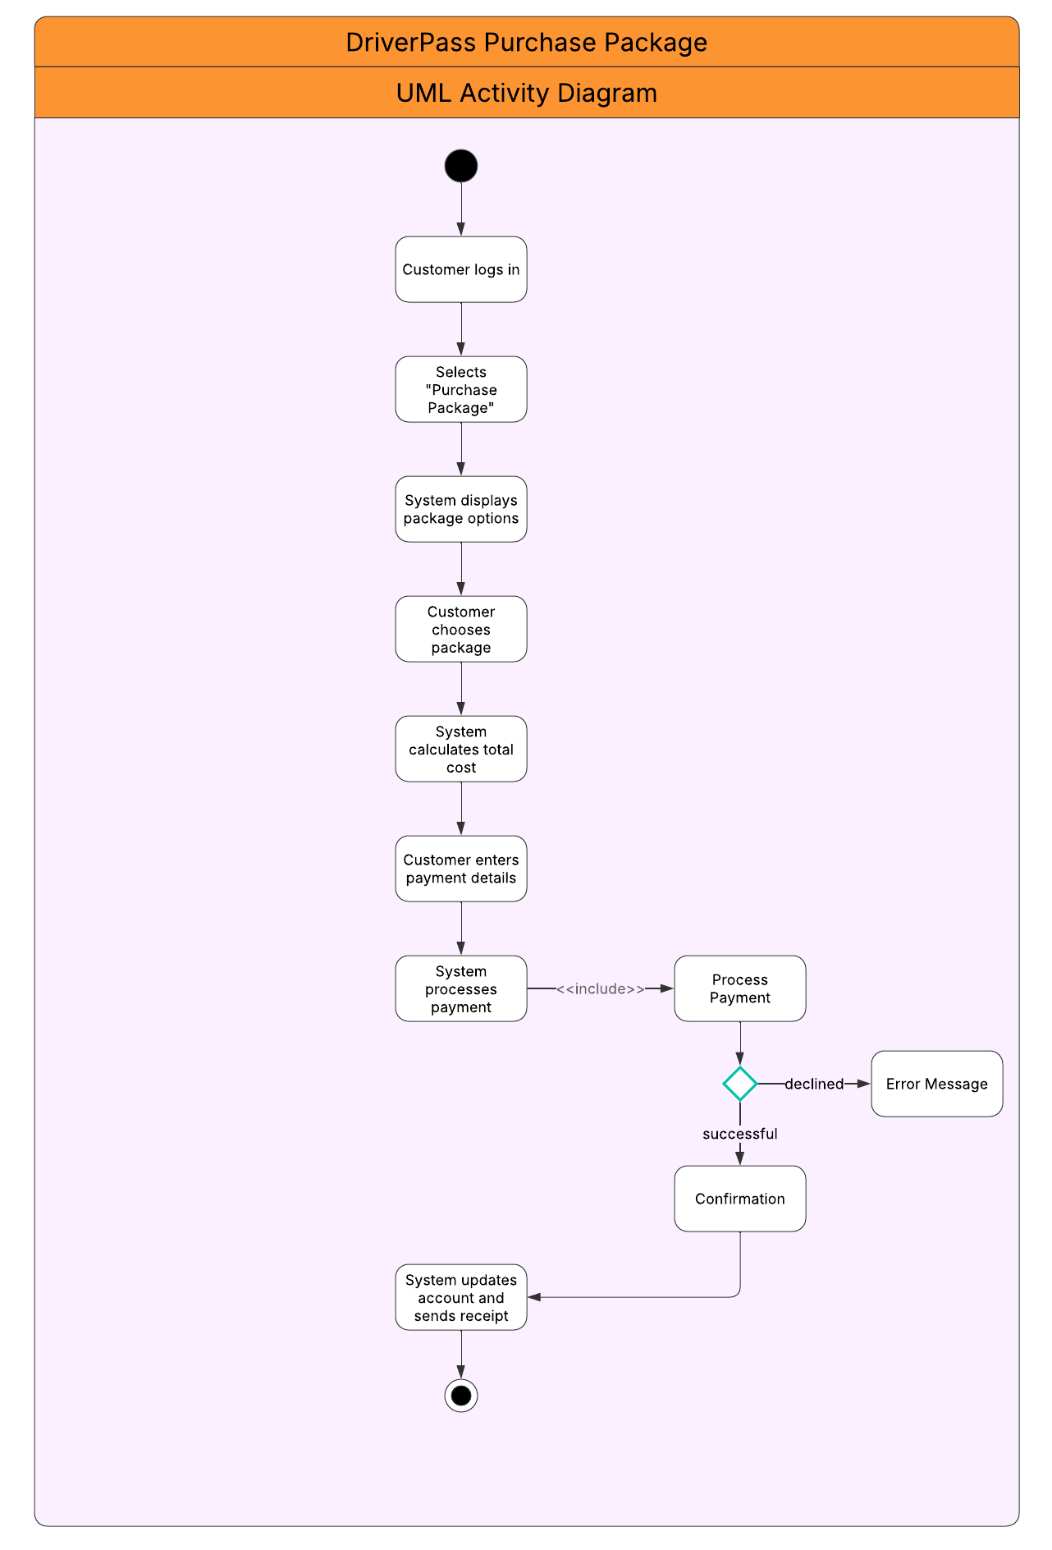

2/2

UML Sequence Diagram
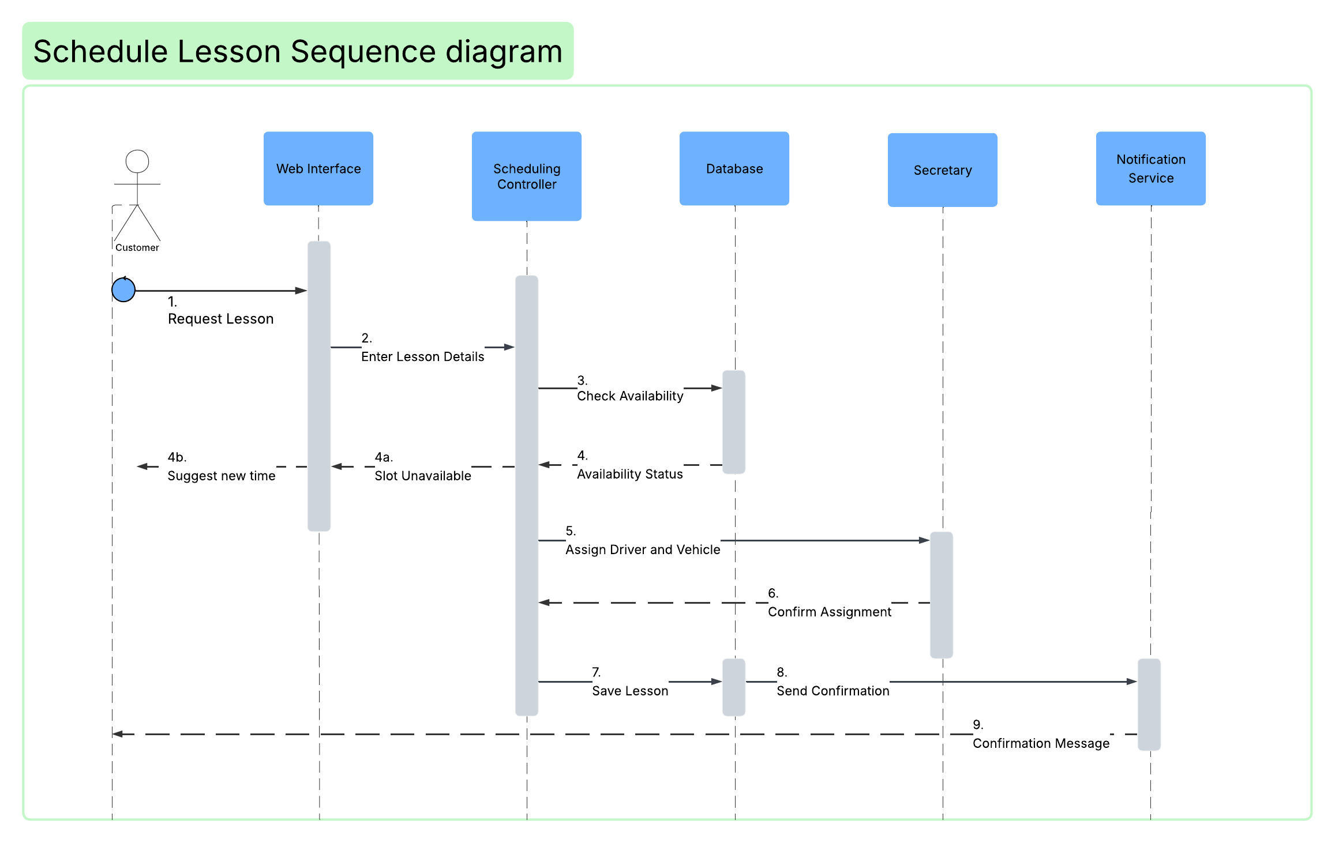

UML Class Diagram
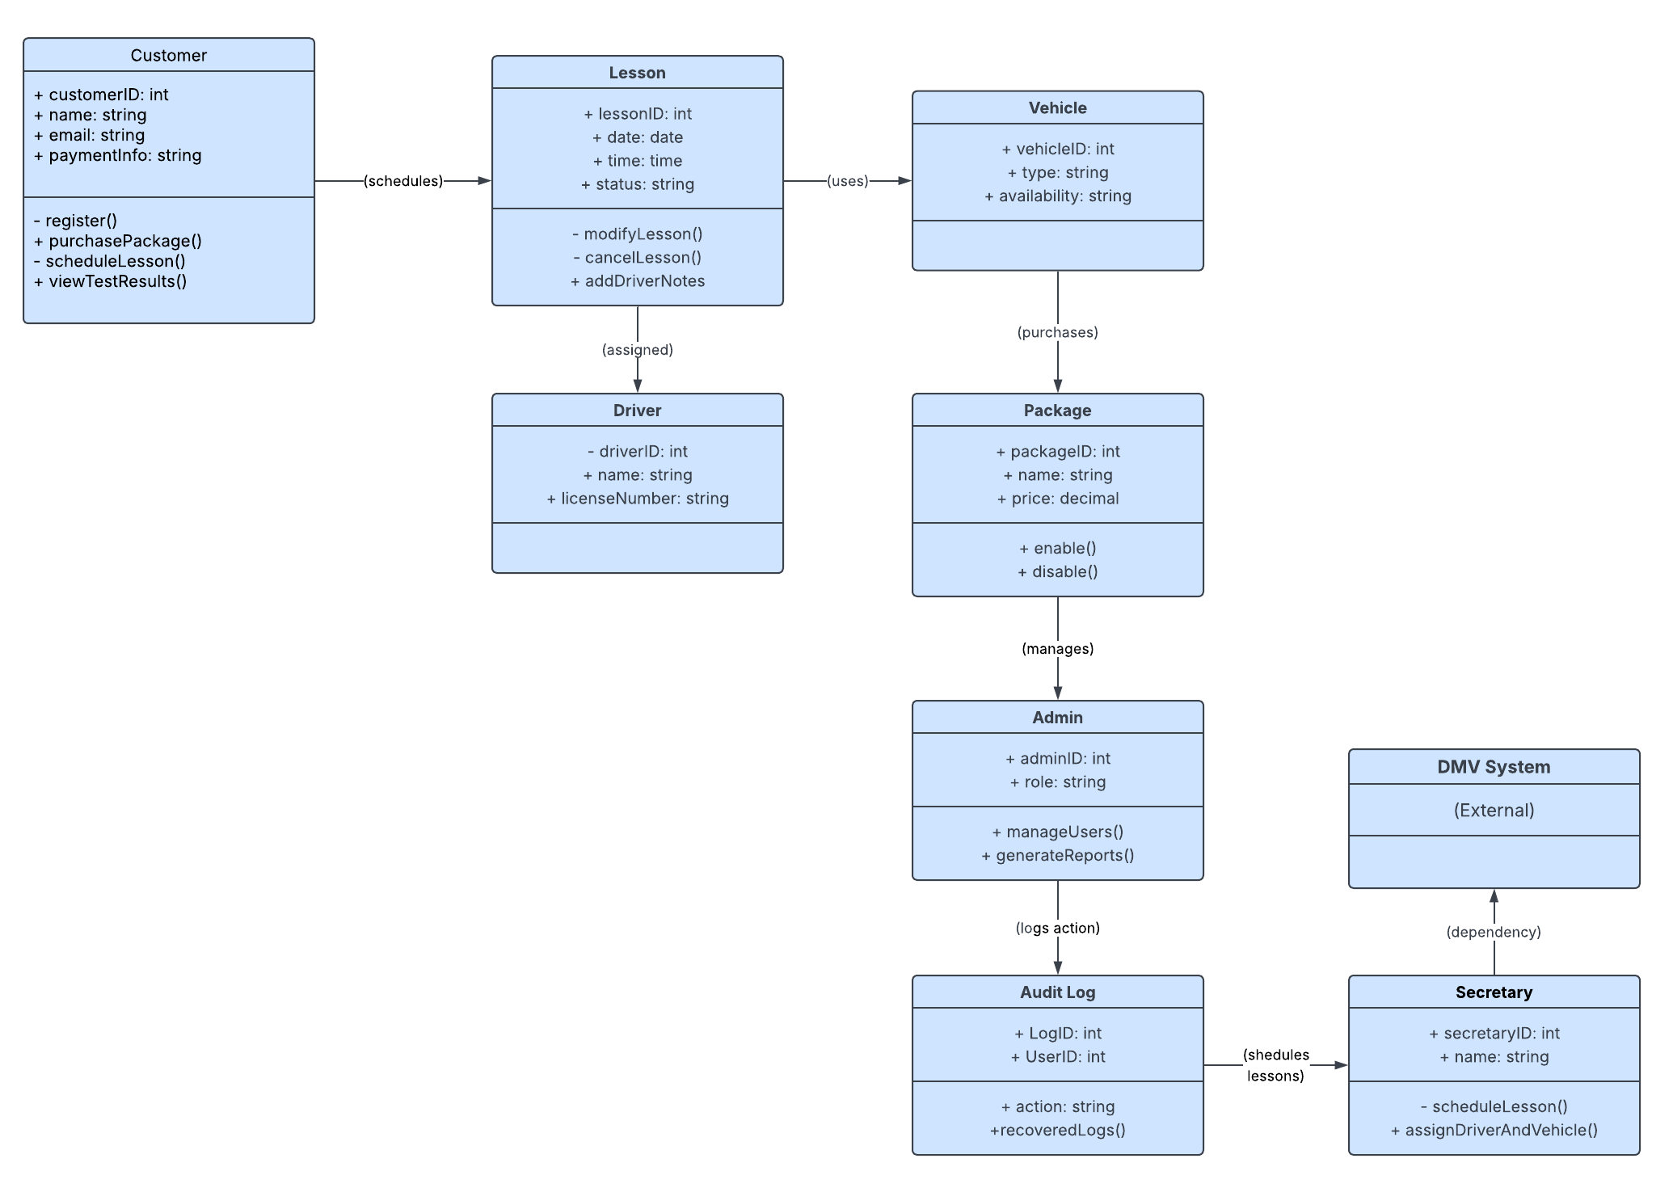

Technical Requirements
The diagrams collectively describe a cloud-based, browser-accessible training and scheduling platform. To support the workflows; account registration, scheduling, payment processing, DMV updates, reporting, and audit logging, the system requires specific hardware, software, tools, and infrastructure.

1. Hardware Requirements
Server-Side Hardware (Cloud Infrastructure)
Because the system is deployed in the cloud, the hosting provider must supply:
- Virtual compute instances capable of running the web application and database
  - 4–8 vCPUs
  - 16–32 GB RAM
  - SSD storage for fast read/write operations
- Load balancers to distribute traffic across application servers
- Auto-scaling to handle peak usage (scheduling rush hours, DMV update pushes)
These requirements support the workflows shown in the sequence diagrams, where multiple components (Web Interface → Controller → Database → Notification Service) operate concurrently.
Client-Side Hardware
End-users only need:
- A desktop, laptop, tablet, or smartphone
- A modern web browser
- Stable internet connection
This aligns with the use case diagram, where all actors interact through the Web Interface.

2. Software Requirements
Server-Side Software
To support the system’s behaviors shown in your diagrams:
Web Application Framework
A backend framework capable of handling authentication, scheduling logic, and reporting:
- Node.js
- Django
- Spring Boot
- ASP.NET Core
This supports the Scheduling Controller, User Management, and Package Management logic shown in the sequence and class diagrams.
Database Management System (DBMS)
A relational database is required for:
- Lessons
- Drivers
- Vehicles
- Packages
- Users and roles
- Audit logs
Supported DBMS options:
- MySQL
- PostgreSQL
- SQL Server
This directly supports the Lesson, Customer, Driver, Vehicle, Package, and AuditLog classes.
Authentication & Security Libraries
- JWT or OAuth 2.0 for secure login
- bcrypt or Argon2 for password hashing
Supports the Log In and Reset Password use cases.
Payment Processing SDK
Required for the Purchase Package use case:
- Stripe
- PayPal
- Square
Supports the Process Payment step in Activity Diagram 2.
Notification Service
Required for:
- Lesson confirmations
- DMV update notifications
Examples:
- SendGrid
- Twilio
Supports the Send Confirmation and Send Notifications interactions in the sequence diagram.

3. Infrastructure Requirements
Cloud Hosting
The system must run on a cloud platform such as:
- AWS
- Azure
- Google Cloud
This supports:
- High availability
- Automatic scaling
- Secure deployment pipelines
Storage & Backup
- Automated daily backups of all database tables
- Redundant storage for fault tolerance
- Versioned backups for audit log integrity
Supports the AuditLog class and the View Audit Logs use case.
Monitoring & Logging
Tools such as:
- AWS CloudWatch
- Azure Monitor
- ELK Stack
Required to support:
- Monitor System Activity use case
- Error detection
- Performance tracking
API Integration
For DMV updates:
- REST API endpoints
- Webhooks or scheduled polling
Supports the Update Rules/Test Content use case.

4. Security Requirements
Authentication & Access Control
- Role-based access control (RBAC) for:
  - Customer
  - Secretary
  - Driver
  - Admin
  - Owner
This matches the actors in the use case diagram and the Admin class in the class diagram.
Data Protection
- HTTPS/TLS encryption for all communication
- AES-256 encryption for sensitive data at rest
- PCI-compliant payment handling
Supports the Process Payment and Manage Users use cases.
System Hardening
- Account lockout after repeated failed login attempts
- Input validation for all forms
- CSRF and XSS protection
Supports the Log In, Register Account, and Reset Password flows.

5. Development Tools & CASE Tools
Modeling Tools
- Lucidchart (used for all UML diagrams)
Development Tools
- Visual Studio Code, IntelliJ, or Visual Studio
- Git for version control
- Postman or Swagger for API testing
Testing Tools
- JUnit, NUnit, Jest, or PyTest for unit testing
- Selenium or Cypress for UI testing
These tools support the system behaviors shown in the activity and sequence diagrams.

